Project phase- report on

# "Design and development Road Spike System"

Made By:

# Ananth Potraje B150231302

**Asjad Khan B150231317**

# Mayur Borude B150231305

**Vivek Pawar B150231341**

B.E. Production (2015 Course)

Under the Guidance of

# Prof. J.H. Shinde



Sinhgad Technical Education Society’s Sinhgad College of Engineering Department of Production Engineering 2021-2022

Pune-411041

Project phase- report on

# "Design and development Road Spike System"

Made By:

# Ananth Potraje B150231302

**Asjad Khan B150231317**

# Mayur Borude B150231305

**Vivek Pawar B150231341**

Has successfully completed their project presentation under the supervision of Prof. Jitendra Shinde for the partial fulfillment of BE Production Engineering of SPPU. This work has not been submitted elsewhere for any degree.

Prof Jitendra Shinde DR. R. S. Katikar

(Project Guide) (HOD)

External Examiner DR. S. D. Lokhande

**ACKNOWLEDGMENT**

To put an effort like this requires the determination and help of many people around us and we would not be doing justice to their efforts by not mentioning each helping hand in person. First of all, I express my heartfelt gratitude to Dr. Rajendra Katikar, Head of Department and other staff member of the Production Engineering department for their kind cooperation. I feel privileged to acknowledge with deep sense of gratitude to my guide Prof. Jitendra Shinde, for his valuable suggestion and guidance throughout the course of our studies and help render to us for the completion of the report. I would like to give sincere thanks to the central library cell and reference library cell and information access centre for their kind cooperation throughout our work.

**Abstract:**

Industrialization and modernization has led to advancements in the field of automobiles. This has eventually led to increase in production rates of vehicles for satisfying the demands for the customers. The ever-increasing production rates are thereby contributing to large extent for traffic problems all over world. Managing this traffic has become a global concern. This has led to wasting time of motorists and passengers ("opportunity cost"). As a non-productive activity for most people, congestion reduces regional economic health. Delays, which may result in late arrival for employment, meetings, and education, resulting in lost business, disciplinary action or other personal losses. This project aims to serve as a solution to traffic problems faced in urban cities. For this “Road Spike System” has been developed which probably helps to control the traffic. The system consists of knife edge elements arranged in series. It punctures the tyres if vehicle tries to cross the traffic signal. The unit consists of cam operated mechanism.

Keywords—DC motor, Microcontroller, Bearing, Shaft, Spikes, RFID Scanner

# INDEX:

Chapter Section No Content Page no

1

Introduction 6

1.1 Overview 7

2 Literature Review 8

3 Block Diagram 12

3.1 Working Principle 13

3.2 Required Components 14

4 Design of Components 15

5 Selection of materials 30

6 Material Selection 39

7 Required Setup 41

7.1 Proposed Algorithm 41

7.2 Application 48

8 Case Study 49

9 Costing of Components 56

10 Conclusion 57

11 Reference 58

**Chapter 1 :- INTRODUCTION**

The traffic congestion problems are increasing day by day because of the increasing number of vehicles with limited infrastructure. Under this situation, the existing traffic light systems which are timer based are not able to control traffic. To overcome this barrier, a real time traffic control and monitoring system by using road spike block. For effective traffic management and signal control, it„s important to know road traffic density. Based on this density value time delay of signals can be set up dynamically. The traffic signal was first discovered in 1912 by a Detroit policeman named Lester Wire like two colour, red-and-green light with a buzzer to warn pedestrians ahead of the impending transition. After that, in 1920, this basic design was updated by William Potts to include the tri-coloured red, yellow, and green lights widely used today. This simple, three-color icon has allowed for nearly a century with little change, using modern technologies such as automatic timers, diode lights and motion sensors. Traffic signals are mainly developed to ensure the correct flow of traffic, provide an opportunity for pedestrians or vehicles to cross a junction and help to reduce the number of collisions between vehicles entering intersections from opposite directions.

The major objective of this system is to provide a safety secured system for our society this

On using the spikes module, the spikes system operates using DC motor. In case ambulance reaches signal the spikes will gets OFF and other signals gets ON with an emergency alert. This system provides a secured system for our society. No other way of breaking the traffic rule. The system will analyze the traffic at four way junction and adjust green light intervals for variable densities of traffic. E.g. If at a traffic signal number of vehicles coming from north & south is too much and that of coming from the east & west is very little, the green light interval for north & southbound traffic will be longer and that for east & westbound traffic will be shorter

**OVERVIEW: -**

* The main objective of this project is to explain about the Road Spike System.
* It is the latest technology which renders help in maintaining the traffic under control.
* It is fully automatic system, as we have seen in many movies and documentaries that the traffic police throw the spike on the road manually in order to stop or slow down the speed of the criminal.
* With the help of this system, it would automatically get activated and the spikes will emerge on the surface of the road eventually compelling the people to follow the traffic rules and regulations.
* Using this model we encourage more and more use of this method, so that hazards occurring because of the traffic gets reduced.

**CHAPTER 2:**

**LITERATURE REVIEW:**

Traffic congestion is a major problem in many cities of India along with other countries. Failure of signals, poor law enforcement and bad traffic management has lead to traffic congestion. One of the major problems with Indian cities is that the existing infrastructure cannot be expanded more, and thus the only option available is better management of the traffic. Traffic congestion has a negative impact on economy, the environment and the overall quality of life. Hence it is high time to effectively manage the traffic congestion problem. There are various methods available for traffic management such as video data analysis, infrared sensors, inductive loop detection, wireless sensor network, etc. All these methods are effective methods of smart traffic management. But the problem with these systems is that the installation time, the cost incurred for the installation and maintenance of the system is very high. Hence a new technology called Radio Frequency Identification (RFID) is introduced which can be coupled with the existing signaling system that can act as a key to smart traffic management in real time. This new technology which will require less time for installation with lesser costs as compared to other methods of traffic congestion management.

IOT Based Smart Transportation System. [2] Published year :2015 Author: J.Sherly1 ,D.Somasundareswari Internet of Things (IoT) links the objects of the real world to the virtual world, and enables anytime, anywhere connectivity for anything that has an ON and OFF switch. It constitutes to a world where physical objects and living beings, as well as virtual data and environments, interact with each other. Large amount of data is generated as large number of devices are connected to the internet. So this large amount of data has to be controlled and converted to useful information in order to develop efficient systems. In this paper, we focus on to an urban IoT system that is used to build intelligent transportation system (ITS). IoT based intelligent transportation systems are designed to support the Smart City vision, which aims at employing the advanced and powerful communication technologies for the administration of the city and the citizens.

IOT Based Dynamic Road Traffic Management. [3]Published year : 2015 Author : Misbahuddin.S, Zubairi.A, Basuni.J .All metropolitan cities face traffic congestion problems especially in the downtown areas. Normal cities can be transformed into “smart cities” by exploiting the information and communication technologies (ICT). The paradigm of arun kamal of Thing (IoT) can play an important role in realization of smart cities. This paper proposes an IoT based traffic management solutions for smart cities where traffic flow can be dynamically controlled by onsite traffic officers through their smart phones or can be centrally monitored or controlled through Internet. We have used the example of the holy city of Makkah Saudi Arabia, where the traffic behavior changes dynamically due to the continuous visitation of the pilgrims throughout the year. Therefore, Makkah city requires special traffic controlling algorithms other than the prevailing traffic control systems. However the scheme proposed is general and can be used in any Metropolitan city without the loss of generality.

**K.Vishnusaravanabharathi:** From this paper he said that the in the usual traffic system the peoples were not following the traffic rules properly. To overcome this problem we were using this system. The main aim of this project is to obey the traffic rules properly if not there will be an opening of spikes. It will make all the people to obey the traffic rules correctly. The major objective of our project is to provide a safety secured system for our society. This project is used to reduce the major accidents in traffic areas and to control the traffic systematically. In addition it also reduces the work of traffic police mans.

**Fred Wegman:** From this paper he Estimates that according to World Health Organization suggest that, on a yearly basis, road crashes kill 1.25 million people—nearly 3400 road fatalities per day—and injure up to 50 million. Traffic injuries are not equally spread over the world, however; some countries are hit harder than others, and the chance of being killed in a road crash depends on where one lives. Almost 90% of all traffic casualties occur in low- and middle-income countries (LMIC). Globally, the number of fatalities per 100,000 populations (mortality rate) ranges from less than 3 to almost 40.

**Sanket Bhansali:** From this paper he said that Industrialization and modernization has led to advancements in the field of automobiles. This has eventually led to increase in production rates of vehicles for satisfying the demands for the customers. The ever increasing production rates are thereby contributing to large extent for traffic problems all over world. This project aims to serve as a solution to traffic problems faced in urban cities. For this “Road Spike System” has been developed which probably helps to control the traffic. The system consists of knife edge elements arranged in series. It punctures the tires if vehicle tries to cross the traffic signal.

**Sanjeev Udenia1:** From this paper he said that Guardian Traffic Systems road blockers, traffic spikes, access controls and CCTV are used to control access to or from airport parking and ground transportation, car rental agencies, car parks, parking garages and airport freight delivery. The Guardian product line is the most extensive, well-engineered and best built product for effective and economical controlled access. Guardian Traffic Systems' tire spike units are available in either surface mount or in-ground applications. Guardian Traffic access controls manage who can go where and when in designated areas. Access Control means management can control who has access to secured areas and at what time, while recording and storing the information.

**5. Ashwini Basavaraju:** From this paper he said that to solve traffic congestion which is a severe problem in many modern cities all over the world. To solve this problem, we have a framework for a dynamic and automatic traffic light control system. Generally, each traffic light on an intersection is assigned a constant green signal time. It is possible to propose a dynamic time-based coordination schemes where the green signal time of the traffic lights is assigned based on the present conditions of the traffic. In this study, we adapt the approach to take data/input/image from object/ subject/vehicle and to process the input data by Computer and Microcontroller and finally display it on the traffic light signal to control the Closed Loop System.

**Chapter 3 – BLOCK DIAGRAM:**

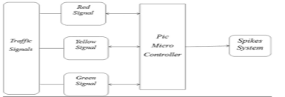

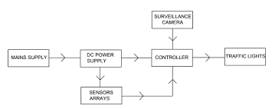

**WORKING PRINCIPLE**

A screw jack or a jackscrew is operated by turning a lead screw. The height of the jack is adjusted by turning the lead screw. This can be done either manually or by integrating an electric motor with it. This integration is our project Main frame is constructed to the required dimension. Jack body mounted on support base which is welded in the main frame. DC geared motor mounted at one end of the lead screw of the jack micro controller operates the dc motor according to the requirements. Battery is required for the power supply which is connected to the dc motor and the micro controller Solar cell is added to charge the battery and to get sufficient power to operate this system.

**REQUIRED COMPONENTS: -**

* Spikes
* Shafts
* Spring
* Power Screw
* Bearing
* Microcontroller
* DC Motors
* Sensors
* RFID Scanner

**CHAPTER 4 - DESIGN OF COMPONENTS:**

SPIKE:

Spike is the main part that we require for building this whole setup.

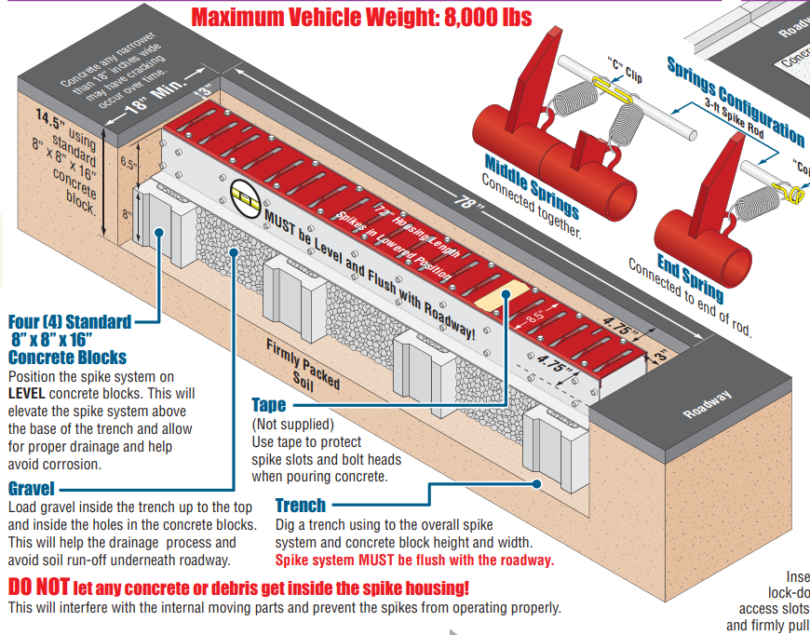

The basic requirements for designing a spike is where we are using it, because spikes have various use in different industries. They are made of using superior quality stainless steel and different other materials; while vehicles. There are a number of added features associated with road spikes or spike barriers that are also called tyre killers. We must develop the spike in a such manner that they are long lasting and durable for any kind of weather as well as the structure of the road.

Moreover the spikes should clearly visible during the nights and rainy or foggy climate, because if the visibility is low it may create havoc and cause a lot of accidents.

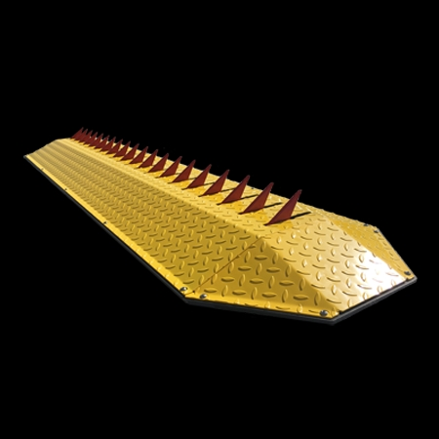

|  |  |
| --- | --- |
| Features | Electro-mechanical |
| Usage/Application | Defence, Embassies, Government buildings, High threat areas etc. |
| For Max Road Width | 2-6m |
| Max Vehicle Load | 30 ton |
| height of spike above ground | 150 MM |
| overall height of spike | 220 to 240 MM |
| Input voltage | 230 V(AC), single phase |
| Safety | Sensors against humans, loop against vehicles |
| spike to spike distance | 100 to 110 MM |
| Opening or closing time | 2-3 sec |
| Minimum Order Quantity | 1 Unit |

**SHAFTS:**

Spike shaft is provided with slots on the top of it. Engagement will lock the spike shaft thereby the conventional differential actions stops and both the wheel shafts get engaged in drive and thus equal power is given to either wheel.

General material used :-

EN24 - Alloy Steel

EN9 - Plain Carbon Steel

MS - Mild Steel

STD - Standard Parts Selected From PSG Design; Data/Manufacturer Catalogu

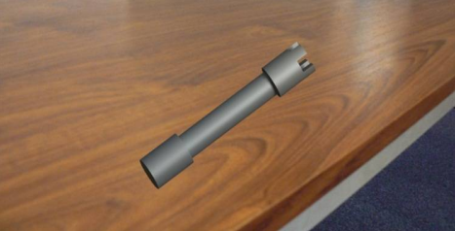

In the above figure, Spike Shaft is shown after completing design in CATIA software.

Material Selection :

|  |  |  |
| --- | --- | --- |
| DESIGNATION | ULTIMATE TENSILE STRENGTH N/mm2 | YEILD STRENGTHN/mm2 |
| EN 24 | 800 | 600 |

**CALCULATIONS**

According to ASME code permissible values of shear stress may be calculated form various relations.

|  |  |
| --- | --- |
| fs max | = 0.18 * σult |
|  | = 0.18 x 800 |
| OR | = 144 N/mm2 |

fs max= 0.3 * σyt

= 0.3 x 680

= 204 N/mm2

Considering minimum of the above values;

fs max= 144 N/ mm2

Shaft is provided with key way; this will reduce its strength. Hence reducing above value of allowable stress by

25%

fs max = 108 N/mm2

This is the allowable valve of shear stress that can be induced in the shaft material for safe operation.

To Calculate Input Torque

POWER = 2πNT/60

T = 60* P/2N

T= 60*50/2πN

Assuming operation speed = 800 rpm

T = 0.5968 N.mm

Assuming 100% overload,

T design = 2 * T

= 2 x 0.5968 x 103

= 1.19 x 103 N.mm

Check For Torsional Shear Failure Of Shaft:-

Assuming minimum section diameter on input shaft = 16 mm

d = 16 mm

Td = π/16 x fsact x d3

fs act = 16 x Td / πd3

fs act  = 1.47 N/mm2

As fs act < fs all

Spike shaft is safe under torsional load.

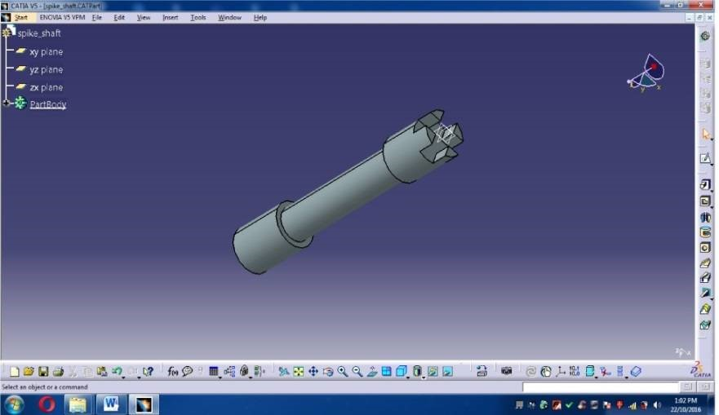

**Figure : Design of Spike Shaft in CATIA**

The above figure is of design of spike shaft done in CATIA after calculations.

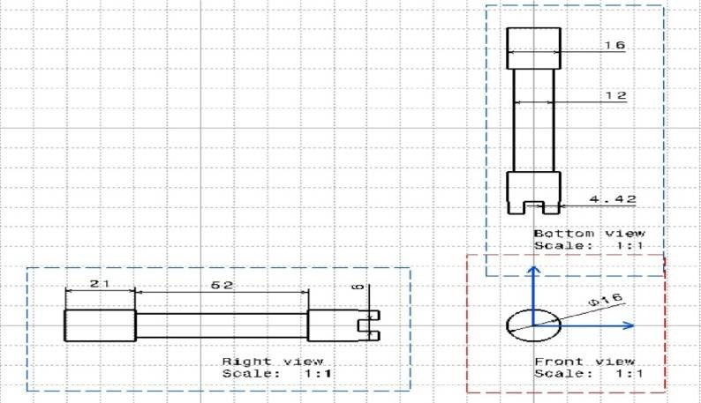

**Figure : Drafting Design of Spike Shaft**

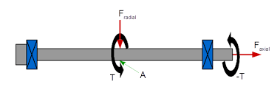

**SPRING:**

Spring is defined as an elastic machine element (flexible element) that deflects under the action of load and returns to its original shape when load is removed.

IMPORTANT FUNCTIONS AND APPLICATIONS OF SPRING

1. Springs are used to absorb shocks and vibrations eg: vehicle suspension springs, railway buffers to control energy, buffer springs in elevators and vibration mounts for machinery.
2. Measuring forces: Spring balances, gages
3. Storing of energy in clocks, toys, novie cameras, circuit breakers, starters
4. Springs are used to apply force and control motion.

TYPES OF SPRINGS

1. Helical coil springs
2. helical compression spring; b) helical extension spring; c) helical torsion spring.

2.Torsion bar springs

3.Leaf spring (beam spring)

4.Volute springs

5.Pneumatic spring

6.Belleville Spring(coned disk spring)



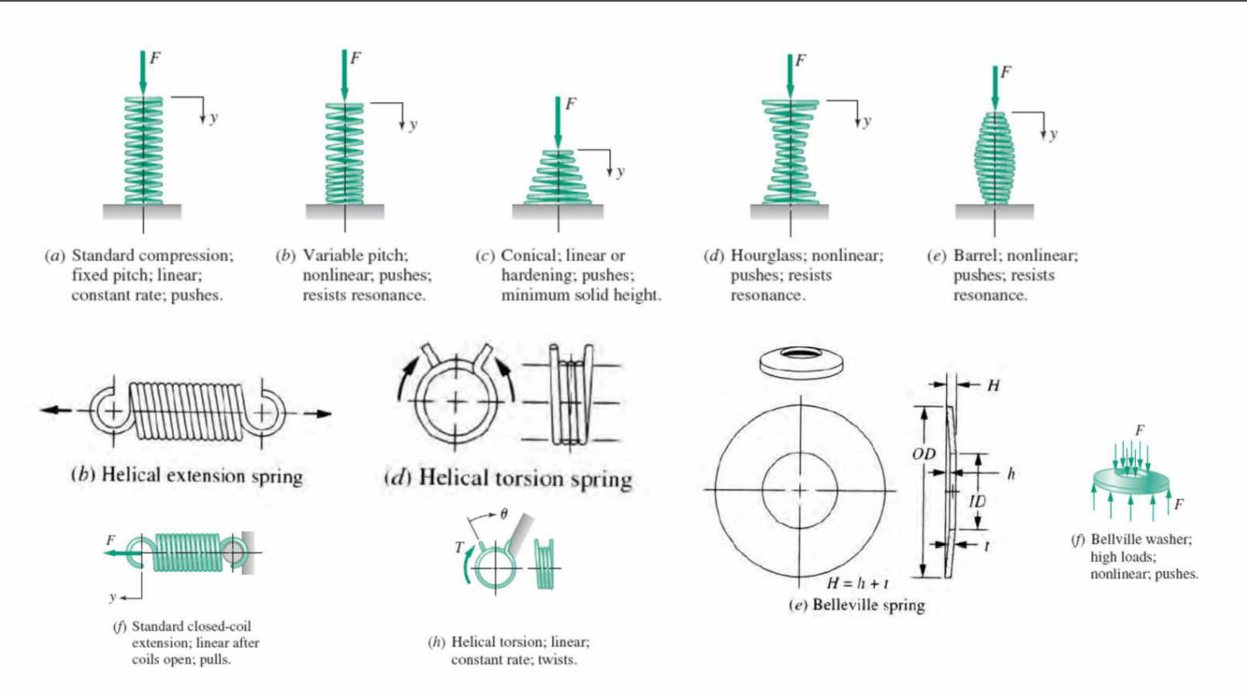

DESIGN PROCEDURE OF HELICAL SPRINGS

Given load F, spring index ‘C’, deflection ‘y’, allowable shear stress ‘t’ and the rigidity modulus G,

Step 1. Design of wire diameter.

Shear stress τ = 8FCK/πd^2

where K = curvature factor = 4C-1/4C-4 + 0.615/C

Find wire diameter ‘d’, select standard wire diameter. (Nearest higher value is to be adopted if calculated value is not standard one.)

Step 2. Mean coil diameter D=Cd

Inside diameter of coil Di=D-d

Outside diameter of coil Do=D+d

**SCREW:**

A screw thread, often shortened to thread, is a [helical](https://en.wikipedia.org/wiki/Helix) structure used to convert between rotational and linear movement or force. A screw thread is a ridge wrapped around a [cylinder](https://en.wikipedia.org/wiki/Cylinder_(geometry)) or [cone](https://en.wikipedia.org/wiki/Cone_(geometry)) in the form of a helix, with the former being called a straight thread and the latter called a tapered thread. A screw thread is the essential feature of the [screw as a simple machine](https://en.wikipedia.org/wiki/Screw_(simple_machine)) and also as a [threaded fastener](https://en.wikipedia.org/wiki/Threaded_fastener).

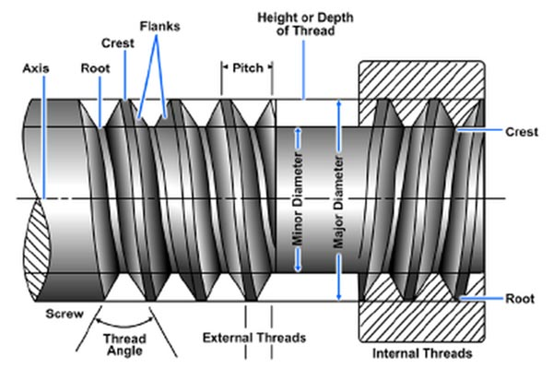

The thread form is the configuration of the thread in an axial plane; or more simply, it is the profile of the thread, composed of the crest, root, and flanks. At the top of the threads are the **crests,** at the bottom the **roots**, and joining them are the **flanks.** The triangle formed when the thread profile is extended to a point at both crests and roots, is the fundamental triangle. The height of the fundamental triangle is the distance, radially measured, between sharp crest and sharp root diameters.

The distance measured parallel to the thread axis, between corresponding points on adjacent threads, is the **thread pitch**. Unified screw threads are designated in **threads per inch.** This is the number of complete threads occurring in one inch of threaded length. Metric thread pitch is designated as the distance between threads (pitch) in millimeters.

On an internal thread, the **minor diameter** occurs at the crests and the **major diameter** occurs at the roots. On an external thread, the major diameter is at the thread crests, and the minor diameter is at the thread roots.

The **flank angle** is the angle between a flank and the perpendicular thread axis. Flank angles are sometimes termed "half-angle" of the thread, but this is only true when neighboring flanks have identical angles; that is, the threads are symmetrical. Unified screw threads have a 30° flank angle and are symmetrical. This is why they are commonly referred to as 60° threads.

**Pitch diameter** is the diameter of a theoretical cylinder that passes through the threads in such a way that the distance between the thread crests and thread roots is equal. In an ideal product, these widths would each equal one-half of the thread pitch.

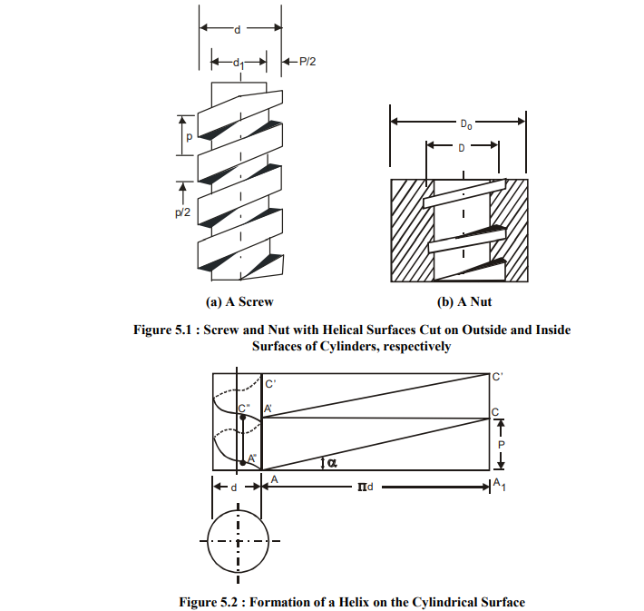

**BEARING:**

For most bearings, the radius of curvature across the pathway of an inner ring is held to 51-52% of the ball diameter while the radius of curvature across the pathway of the outer ring is held to 53-54% of the ball diameter. As the pathway radius of curvature approaches 50% of the ball diameter (100% of the radius), the stress between the ball and pathway decreases; however, it also moves the contact of the ball higher up the pathway wall producing more friction as the balls revolve around the bearing. For ball bearings, the best balance between stress and friction is attained with the pathway curvature slightly above 50% as described above for inner and outer rings. The number is higher for outer rings because, in the rotational plain, outer rings present a concave surface to the balls lowering the contact stress compared to the inner rings which, in the rotational plane, present a convex surface to the balls raising the stress.

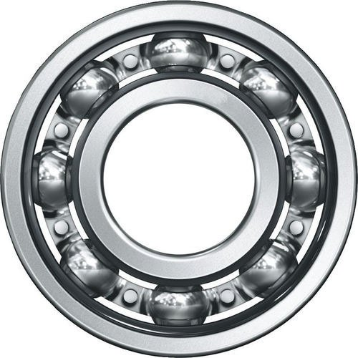

As previously described, the raised surface on each side of the pathway is called the shoulder. The radial difference between the deepest part of the pathway to the OD of the inner ring and to the ID of the outer ring is called the shoulder height. In most bearings it is held to 22-30% of the ball diameter for inner rings and 18-22% for outer rings, with the difference being due to the same reason that the pathway curvatures are not the same for inner and outer rings. The design height of the shoulder is a balance between being high enough to support proportionately high thrust (side) loads and low enough to be able to assemble an adequately sized separator into the bearing. Another design consideration is the minimum wall thickness at the bottom of the pathway of both the inner and outer rings. This section must be thick enough to simultaneously support compressive stresses from the balls on the inside and hoop stresses from press fit assembly on the outside.

Assembly of most ball bearings is as follows:

* On a flat surface the inner ring is placed off-center inside the outer ring.
* The balls are loaded inside the crescent shape that is formed.
* The inner ring is centered and the balls evenly spaced.
* The separator is installed.

Conrad Assembly of Bearings

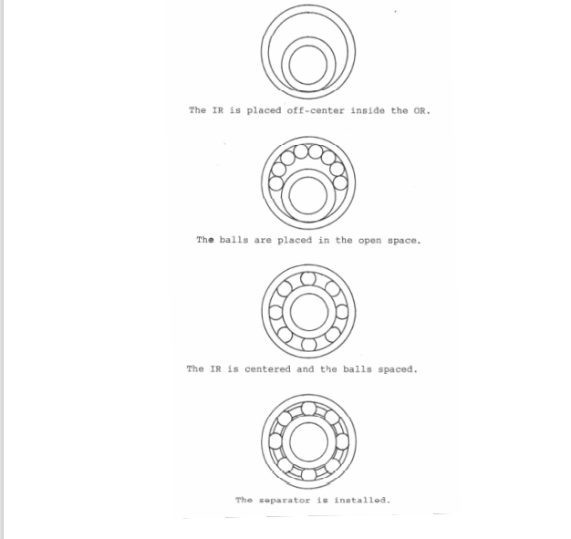

Ball Bearing Material:

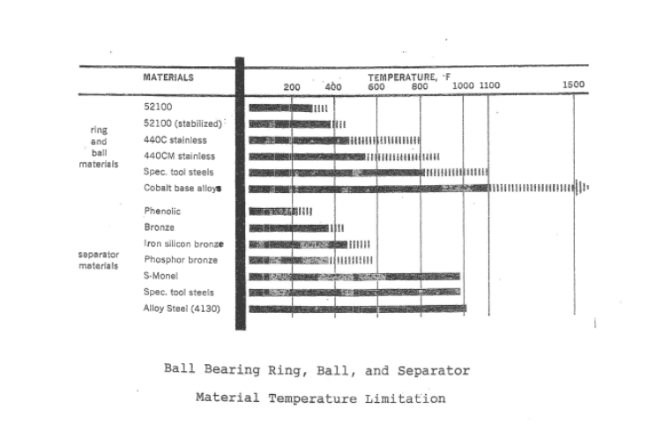

**CHAPTER 5:**

**SELECTION OF COMPONENTS:**

**MICROCONTROLLER (8051):**

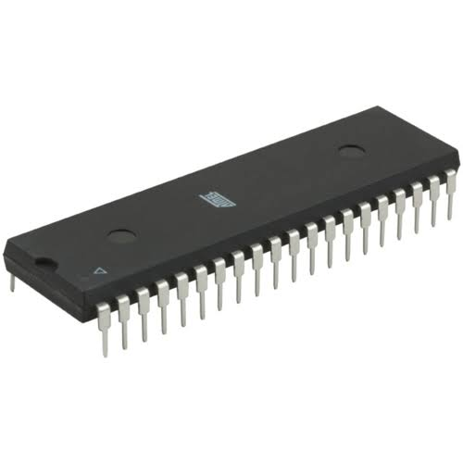 Microcontroller is a small computer on a single integrated circuit. In modern terminology, it is similar to, but less sophisticated than, a system on a chip; one may include a microcontroller as one of its components.

**Fig. Microcontroller**



Microcontrollers are used in automatically controlled products and devices, such as automobile engine control systems, implantable medical devices, remote controls, office machines, appliances, power tools, toys and other embedded systems. By reducing the size and cost compared to a design that uses a separate microprocessor, memory, and input output devices, microcontrollers make it economical to digitally control even more devices and processes.

**Features**

* Control Registers like PCON, SCON, TMOD, TCON, IE, and IP.
* 16-bit Timers or Counters -2 like T0 & T1.
* Program Counter – 16 bit & DPRT (DThe main features of the 8051 microcontroller architecture include the following.
* 8-bit CPU through two Registers A & B.
* 8K Bytes – Internal ROM and it is a flash memory that supports while programming the system.
* 256 Bytes – Internal RAM where the first RAM with 128 Bytes from 00H to 7FH is once more separated into four banks through 8 registers in every bank, addressable registers -16 bit & general-purpose registers – 80.
* The remaining 128 bytes of the RAM from 80H to FFH include Special Function Registers (SFRs). These registers control various peripherals such as Serial Port, Timers, all I/O Ports, etc.
* Interrupts like External-2 & Internal-3
* Oscillator & CLK Circuit.
  + I/O Pins – 32 which are arranged like four ports such as P0, P1, P2 & P3.
  + Stack Pointer (SP) – 8bit & PSW (Processor Status Word).
  + Serial Data Tx & Rx for Full-Duplex Operation

**DC MOTOR:**

A DC motor is any of a class of rotary electrical machines that converts direct current electrical energy into Mechanical energy. The most common type of rely on the forces produced by magnetic field. Nearly All types of DC motors have some internal mechanism, either electromechanical or electronic; to periodically Change the direction of current flow in part of the motor.

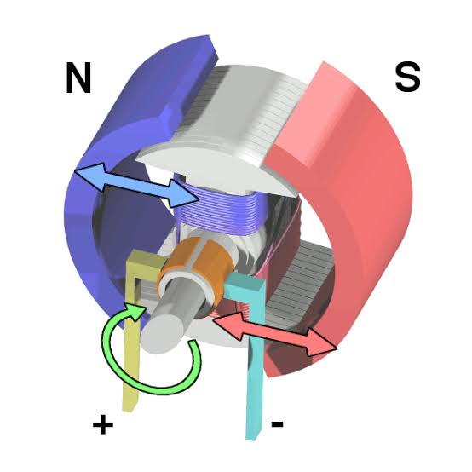

**Fig. DC motor**

DC motors were the first type widely used, since they could be powered from existing direct-current lighting Power distribution systems. A DC motor’s speed can be controlled over a wide range, using either a variable Supply voltage or by changing the strength of current in its field windings. DC motor is used to operate the spikes.

FEATURE

* Selective high security and safety mode.
* Spike sector can move independently.
* Manual operation in case of power failure
* High torque DC motor for greater rehabilitee
* External limit switches provide fail safe operation.
* Robust construction builds to with stand greater impact.
* Emergency lowering or up possible in case of threat fire.
* Electronic forces can be adjusted through programming levels.
* Indirect drive modal can operate independently of traffic barrier unit.

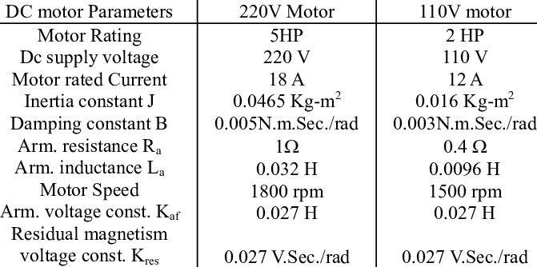

SPECIFICATION: -

|  |  |
| --- | --- |
| **PARAMETER** | **DETAILS** |
| Material | Galvanized mild steel |
| Type | Flat/Hump |
| Drive | Electro-mechanical |
| System configuration | 3-6m |
| Operating closing time | 3-5sec |
| Power supply | 230V,50HZ |
| Spike material | AISI 304 |
| Blocking angle | 60 degrees |
| Load capacity | 25/50 TON |
| Environment temperature | 200C TO 550C % 95 non-condensing humidity |
| Power consumption | 100W |

**SENSORS: -**

The sensors also play an important role in managing the whole. The density of traffic as well as detecting a vehicle from a far away distance, these all functions are performed by the Sensor. For this purpose, we use the Proximity Sensor.

A Proximity Sensor is a sensor able to detect the presence of nearby objects without any physical contact. A proximity sensor often emits an electromagnetic field or a beam of electromagnetic radiation (infrared, for instance), and looks for changes in the field or return signal.

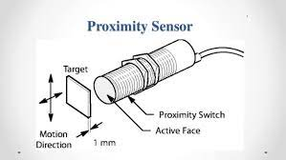 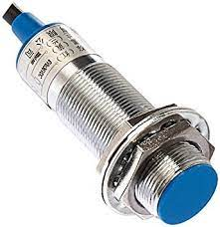

**Fig. Proximity Sensor**

We have mostly witnessed Proximity Sensor in the parking lots, as soon as the vehicle enters the field the barrier comes down and once the fees is paid the barrier moves up.

The proximity of the object is detected by a change in capacitance. The sensor can also be used to detect a wide variety of non-metallic and metallic objects and typically operate over a range of 3 to 30 mm.

### Principles of operation

|  |  |  |  |  |  |  |  |
| --- | --- | --- | --- | --- | --- | --- | --- |
| [A proximity sensor](https://www3.panasonic.biz/ac/ae/fasys/sensor/proximity/index.jsp) detects the approach of an object without making a contact. There are three types of proximity sensors:   |  |  | | --- | --- | | 1) | High-frequency oscillation type using electromagnetic induction | | 2) | Magnetic type using magnetism | | 3) | Electrostatic capacity type which senses the changes in the electrostatic capacity between the sensing object and the sensor. | |  |

### Principle of high-frequency oscillation type inductive proximity sensor:

The detection coil located at the front end of the sensor produces a high-frequency magnetic field as shown in the figure below. When an object (metallic) approaches this magnetic field, induced currents flow in the metal, causing thermal loss and resulting in the reduction or stopping of oscillations.  
This change in state is detected by an oscillation state sensing circuit which then operates the output circuit.

**RFID SCANNER:-**

A radio frequency identification reader (RFID reader) is a device used to gather information from an RFID tag, which is used to track individual objects. Radio waves are used to transfer data from the tag to a reader. RFID is a technology similar in theory to bar codes.

RFID is a technology similar in theory to bar codes. However, the RFID tag does not have to be scanned directly, nor does it require line-of-sight to a reader. The RFID tag it must be within the range of an RFID reader, which ranges from 3 to 300 feet, in order to be read. RFID technology allows several items to be quickly scanned and enables fast identification of a particular product, even when it is surrounded by several other items.



RFID tags have not replaced bar codes because of their cost and the need to individually identify every item.

RFID technology may be used in a variety of applications including:

* Passports
* Smart cards
* Airplane luggage
* Toll booth passes
* Home appliances
* Merchandise tags
* Animal and pet tags
* Automobile key-and-lock
* Monitoring heart patients
* Pallet tracking for inventory
* Telephone and computer networks
* Operation of spacecraft and satellites

**CHAPTER 6:**

**MATERIAL SELECTION: -**

Materials are selected on the basis of four general criteria: Performance characteristics (properties), Processing characteristics (manufacturing), Environmental profile, Business consideration. So, based on the criteria and the specification we need for our design which is a material with high weight to strength ratio, available in the market, and have a competitive value. After searching for the perfect material we found out that the best material to use in manufacturing our parts is mild steel. Mild steel, also known as plain-carbon steel, is now the most common form of steel because its price is relatively low while it provides material properties that are acceptable for many applications.

Low-carbon steel contains approximately 0.05– 0.15% carbon making it malleable and ductile. Mild steel has a relatively low tensile strength, but it is cheap and easy to form; surface hardness can be increased through carburizing. It is often used when large quantities of steel are needed, for example as structural steel. The density of mild steel is approximately 7.85 g/cm3 (7850 kg/m3 or 0.284 lb/in) and the Young's modulus is 210 GPa (30,000,000 psi).

Low-carbon steels suffer from yield-point runout where the material has two yield points. The first yield point (or upper yield point) is higher than the second and the yield drops dramatically after the upper yield point. If low-carbon steel is only stressed to some point between the upper and lower yield point then the surface may develop Luder bands. Low-carbon steels contain less carbon than other steels and are easier to cold-form, making them easier to handle.

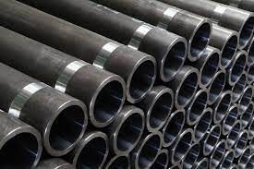

**Fig. Material**



**CHAPTER 07:**

**PROPOSED SYSTEM ALGORITHM:**

Figure below is a flowchart showing the process of time Allocation to vehicles plying the road at a given junction. The Algorithm describes the timing process for one lane at the junction Which is replicated at different time intervals in the actual Implementation.

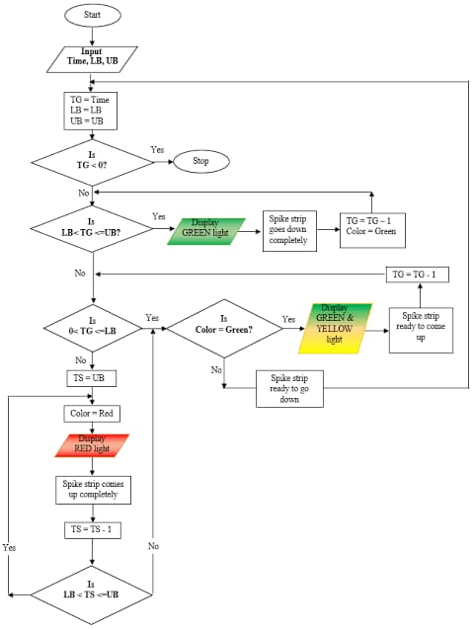 **Fig. Flowchart diagram**

Figure : Flowchart Diagram for Traffic Light System using Smart Spike Strip (SSS) for one lane at the traffic Junction Figure above illustrate the flow of events or data and how they Respond with the timer when they are scheduled on different time Interval. There are four (4) acronyms used namely:

“Time to go” represented as “TG”

“Time to stop” represented as “TS”

“Lower bound” represented as “LB”

“Upper bound” represented as “UB”

TG is the time frame for the motion lane to be active – that is Vehicles are granted the right of way while the spike strip stays Down completely. TS is the waiting time frame for the vehicles on A static lane as the spike strip is up completely. LB and UB is the Time frame or boundaries set for vehicles to either get ready to Stop or get ready to go depending on the situation of the time. The pseudo code for the flowchart in figure is shown in table 1 Below with a brief explanation of the process.

pseudo code for traffic light system using smart spike strip

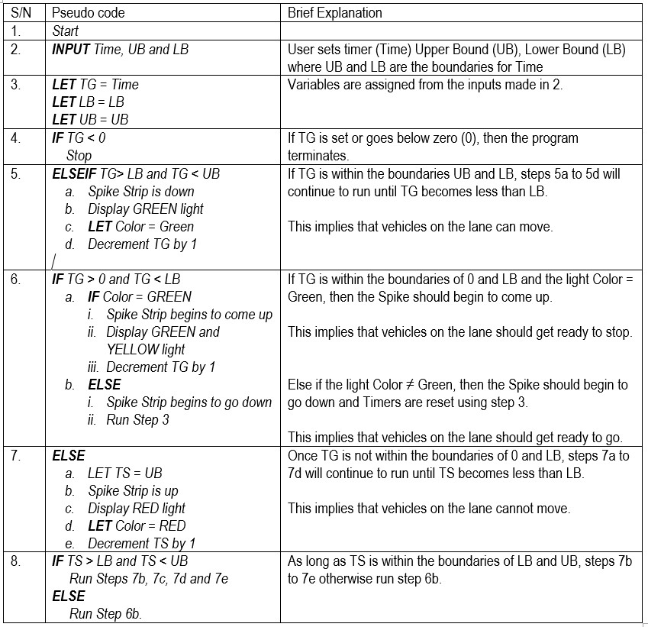

Table : pseudo code for traffic light system using smart spike strip

**APPLICATION: -**

1. Traffic controlling on road: For controlling traffic on road & to obey traffic system road spike system is used. For automatic controlling vehicle density sensor used in this according to the presence of vehicle on road the signal get changes and system operated discus below.

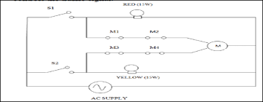

Fig Circuit Diagram

It consists of following parts: Synchronous Motor, Micro switches, Shaft, Spikes, spring .The working of the circuit has been done using normally open switches, for ease of demonstration. IN actual practice it would be actuated using a micro controller AT89S51 which controls the traffic signal.

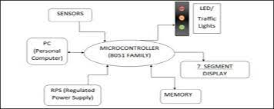

Vehicle Density Sensor Block Diagram

Case 1: When the signal changes to red When the red switch is pressed it closes the switch S1 while switch S2 remains open. When switch S1 is activated it simulates a red signal which runs two parallel circuits one which switches on the red light and the other which activates the motor , the motor circuit has limit switches M1 and M2 (normally closed ) in series with the motor. When the red light is ON the motor rotates in a anticlockwise direction (when viewed from the motor to the model). The spike will move up.

Case2: When the signal changes to amber. When the amber switch is pressed it closes the switch S2while switch S1 remains open. When switch S2 is activated it simulates amber signal which runs two parallel circuits, one which switches on the amber light and the other which activates the motor. The motor circuit has limit switches M3and M4 (normally closed) in series with the motor. When the amber light is ON the motor rotates in a clockwise direction (when viewed from the motor to the mode). The spike moves down.

Case 3: When the signal changes to green. During the red signal the spikes rises above the road surface and during the amber signal the spikes lowers below the road surface and stays stable throughout during the green signal. Hence during the green signal there would be no change in the system that is both the witches S1 & S2 remain open during the green signal.

1. For BRT:As BRT only use for government vehicle &ambulance only, but lot of other vehicles are pass through BRT so to avoid this the road spike system is used as shown in in Fig.

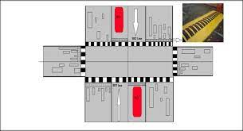

Road Spike Place on Road

The system operation done by providing RFID tag to the all-government vehicle (buses), ambulance. The RFID reader sense the when vehicle pass close through it and pass signal to microcontroller. The microcontroller controls the motor and up down movement of spike can be done. Radio Frequency Identification Sensor (RFID): Radio-frequency identification (RFID) uses electromagnetic fields to automatically identify and track tags attached to objects.

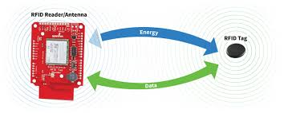

RFID

The tags contain electronically stored information. Passive tags collect energy from a nearby RFID reader's interrogating radio waves. Active tags have a local power source (such as a battery) and may operate hundreds of meters from the RFID reader. Unlike a barcode, the tag need not be within the line of sight of the reader, so it may be embedded in the tracked object. RFID is one method for Automatic Identification and Data Capture (AIDC).

Case Study:

Here we have two case studies with us, the first on is of China and second is of Nigeria. Road spike system has been a huge success in many countries including India. So now let’s see some other countries.

# A Simulation to Minimize Traffic Violation in Nigeria Through the Use Of Smart Spike Strip :-

**Traffic light violations always have negative effects on lives and environment and to quantify these negative effects is complex. For traffic light violation to be mitigated or eliminated, gathering of information on traffic incidents such as nature of the road, congestion spots, and volume of traffic on each road cannot be overemphasized. The elimination of traffic light violation particularly in developing countries like Nigeria may not be a realistic goal, but controlling or managing it to reduce the intensity of violation may be achievable. The unbearable traffic congestion is the highest cause of traffic light violation, most especially within the rush hours of the morning when individuals go to work (between 7.00am-8.00am) and coming back in the evenings (4.00-5.00pm and 6.00-7.00pm) at most cross roads in Kaduna metropolis. In this research work, an algorithm is developed to control the traffic light violation on one lane of a traffic junction by introducing the smart spike strip which is synchronized with the traffic light control system. The implementation of the algorithm to simulate the control of the traffic light violation on a traffic junction is achieved using Visual Studio 2012 IDE as a platform for the simulation. Screenshots to illustrate the different of the vehicles and lanes which are states static, ready and motion states shown.**

**Algorithm Demonstration:**

**A simple demonstration will be created for illustration purpose of the algorithm designed in section 8 above using the variables in table 2.**

|  |  |
| --- | --- |
| **Variables** | **Value (Seconds)** |
| **Time** | **30** |
| **Upper Bound** | **30** |
| **Lower Bound** | **5** |

**Once the variables “Time”, “UB” and “LB” are entered as 30, 30 and 5 respectively for instance. The values are initialized and assigned to the variables accordingly. The units of the values are in seconds.**

**As long as “TG” is within “LB” and “UB”, which is 5secs and 30secs respectively, two things will take place:**

**• The green light is displayed and**

**• Spike strip is completely down**

**On the other hand, once “TG” fall within the zero (0) and “LB” which is 5secs, two things will happen:**

**• The green light and yellow light is displayed to mean “get ready to stop” and**

**• Spike strip will be getting ready to come up.**

**At this point, a variable Color would have been initialized to green to be used to differentiate the time vehicles are to stop and the time vehicles are to go. If Color = “green” and the time frame is within zero (0) and 5, it implies that, the traffic light display is green and yellow indicating that vehicles should get ready to stop as the spike strip will be getting ready to come up as well. On the other hand, if the Color = “red” and the time frame is within zero (0) and 5, it implies that, the traffic light display is yellow indicating that vehicles should get ready to go as the spike strip will be getting ready to go down as well.**

**Simulation Tool :**

**The simulation of the traffic light violation control with smart spike strip (SSS) was implemented using the Visual Studio 2012. The software can be used to create an environment that illustrates the proposed concept. For instance, the road intersection, vehicle pictures, vehicle movements, spike strips and traffic lights was created using this tool.**

**System Implementation:**

**At implementation of the traffic light system, the tool that was used to achieve the goal of simulating traffic light violation control using smart spike strip (SSS) is Visual Studio 2012. Figures 2 shows a screenshot of a typical simulation of the traffic light system with different events. There are three (3) different states shown namely:**

**1. Static state**

**2. Ready state**

**3. Motion state**

**Demonstration of the following states are shown with the help of diagram:**

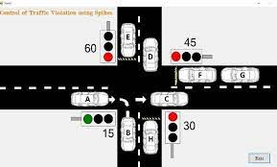

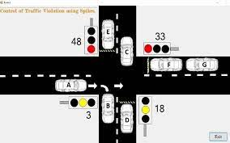

**The vehicles labeled A, B, C, D in figure 2 and A, B in figure 3 above are said to be on motion state, which means that the traffic light control system has given all vehicles on the lanes the signal to go while the spike is down. The time remaining for vehicles on the motion lane in figure 2 before changing to static state is 15 seconds while the time remaining for vehicles on the motion lane in figure 3 before changing to static state is 13 seconds. The lane with vehicles labeled E, F, G, H in figure 2 and C, D, E, F in figure 3 above are said to be on static state which means that the traffic light control system has signaled all the vehicles on their lane to stop while the spike is up. The lane with vehicles labeled A, D in figure 4 are said to be on ready states. This means that vehicle A has 3 seconds to use the lane as the traffic light control system is getting ready to change to static state and bring up the spikes. Vehicle D on the other hand is on ready to go state. This means that the traffic light control system on that lane has signaled the vehicles to get ready to move as the spike is getting ready to go down.**

**China’s Automatic Retractable Barrier Road Block for Traffic with Stinger Spike System:**

**SPT650 Portable deceleration slope type roadblock, also known as tyre killer. It belongs to the electromechanical integrated remote control to intercept the car. The roadblock uses more than 100 hollow stainless-steel needles to directly pierce the tires of unauthorized vehicles.  
  
The size of the spike barrier collection can be put into the trunk of the trolley. When it is needed, the spike barrier can be opened in the traffic lane. The user can remote control the spike rising within 200 meters. To prevent the vehicle can't continue driving after the tire has been deflated. The effective length can be produced to 5-16 meters according to the user's requirements**

|  |  |
| --- | --- |
| **Items** | **Specs** |
| **Function** | **Digital display work, wireless remote control start and close studs** |
| **Effective Interception Distance** | **6-15 meters (in options)** |
| **Puncture Tire Thickness** | **≤35mm** |
| **Max weight capacity** | **20T** |
| **Remote control speed** | **≤ 1 time / sec** |
| **Remote control distance** | **45 meters (Empty zone)** |
| **Spike Barrier Weight** | **16 kgs** |
| **Standard Spike Barrier Size** | **6000(L)*240(W)*30(H)mm** |
| **Working Voltage** | **12V** |
| **Venting Hollow Steel Needle Size** | **φ5mm×43mm** |
| **Packing box size** | **630(L)*610(W)*280(H)mm** |
| **Gross weight(6m)** | **34 kgs** |

**Comes with accessories:**

**1. Remote control box: 1 unit**

**2. Control cable : 1 unit**

**3. Car power supply connection cable: 1 unit**

**4. Deflated hollow needles: 10 units (with rubber sleeve)**

**5. Charging cable : 1 Unit**

**6. Needle replacing tools: 1 unit**

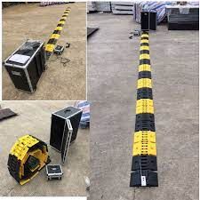

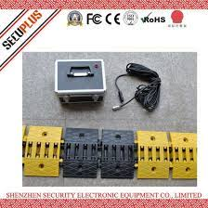 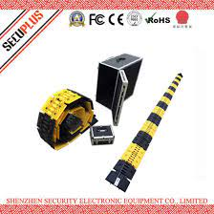

**CHAPTER 09**

**COSTING OF COMPONENTS: -**

|  |  |
| --- | --- |
| Components | Cost |
| Spike | Rs 8500 |
| Microcontroller | Rs 6000 |
| DC Motor | Rs 5500 |
| Sensors | Rs1480 |
| Shafts | Rs 340 |
| Paint | Rs 12-35 per sq. ft. |
| Springs | Rs 150 |
| Concrete | Rs 2500 to 2650 per cubic metre |
| RFID Scanner | Rs 650 |
| Steel Rods | Rs 50-55 Kg |
| Holding Tools | Rs 8800 |
| Total Costing | Rs 34125 |

-

**CHAPTER 10:**

**CONCLUSION: -**

The outset of the project, the Road Spike System was chosen as the most suitable conceptual design for satisfying the problem statement. Consequently, the main objective module was to Develop a mechanism for Road Spike System. The module was concluded successfully and the result was a suitable design satisfying the earlier demands. The mechanism was developed on the basis of the Rule of Thumb and ease of manufacturing, availability of components at short lead times. One more aspect of the project was to reduce the traffic management problem and inculcate behavior of following traffic rules and regulations in citizens. The machine is also important from the point of view of security application to the potential customers. Thus, the project was concluded to be successfully and beneficial for the overall development of both the society and the students.

**CHAPTER 11:**

**REFERENCES**

[1] PallaviChoudekar, Sayanti Banerjee, et al “Real Time Traffic Light Control Using Image Processing” IJCSE Vol. 2 No. 1

[2] Kavya P Walad, JyothiShetty et al “Traffic Light Control System Using ImageProcessing” IJIRCCE Vol.2, Special Issue 5, October 2014.

[3] R.Prabhu,M. Premalatha “Traffic Control System For Congestion Control,Ambulance Clearance And Stolen Vehicle Detection” IJMTER Volume 03, Issue 05

[4] Monish Puthran, Sangeet Puthur, and Radhika Dharulkar “Smart Traffic Signal” in (IJCSIT) International Journal of Computer Science and Information Technologies, Vol. 6 (2), 2015, 1360- 1363, 2015.

[5] Ashwini Basavaraju, Senhalata Doddigarla, Navitha Naidu, Shruti Malgatti “Vehicle density sensor system to manage traffic” in IJRET: International Journal of Research in Engineering and Technology eISSN: 2319- 1163 | pISSN: 2321-7308, 2014.

[6] Abdelrasoul Jabar Alzubaidi, Arwa Abdel Mohsen Ahmed Hassan, “Design of semi-automatic traffic light control system” in International Journal Of Scientific & Technology Research Volume 3, Issue 10, October 2014 Issn 2277-8616, 2014

[7] Science World Journal Vol. 14(No 3) 2019 www.scienceworldjournal.org ISSN 1597-6343 Published by Faculty of Science, Kaduna State University

[8] International Journal of Engineering Research & Technology (IJERT) ISSN: 2278-0181 IJERTV4IS070626 www.ijert.org (This work is licensed under a Creative Commons Attribution 4.0 International License.) Vol. 4 Issue 07, July-2015

[9] Resincap Journal of Science and Engineering Volume 3,Issue 11 November 2019 ISSN: 2456-9976

[10] AUTOMATIC ROAD SPIKER Prof. Laxman1 , Pavan.S2 , Shiva kumar3 1Asst.Professor, 2,3UG Students, Department of Mechanical Engineering, Shri Pillappa College of Engineering, Bangalore (India)

[11] Traffic Spike System Sanjeev Udenia1 , Meenu Bhati2 1Department of ECE, Global College of Technology, Jaipur

[12] Road Spike System Used For Different Application Ambekar Shantanu1 , Rohan Kare2 , Ambekar Shubham3 1 Student at, Mechanical Department, Imperial College of Engineering and Research, Pune. 2Assistant Proof, Mechanical Department, Imperial College of Engineering and Research, Pune. 3 Students at, Mechanical Department, Shree RamChandra College of Engineering, Pune.